|  |  |  |  |
| --- | --- | --- | --- |
| PS_Logo | StadtPirmasensPress Release |  |  |

Pirmasens, 5. December 2024

**Successful Relaunch for PETER KAISER in the Shoe City of Pirmasens**

* **The first PETER KAISER collection (Spring/Summer 2025) following the takeover of the traditional women’s shoe brand by the shoe manufacturer CAPRICE is now available at more than 700 specialty retail partners.**
* **The classic pump line has been expanded to include sneakers, sporty ballerinas, sandals, and party shoes – the Fall/Winter 2025/26 collection will also reintroduce stretch leather boots, among other highlights.**

The proud history of PETER KAISER is also an impressively long chapter in the story of Pirmasens. For context: when the brand’s namesake founded the first German shoe factory in the western Palatinate city in 1838, the entire region was still part of the Kingdom of Bavaria. That same year marked the maiden journey of Germany’s first railway line between Nuremberg and Fürth. The renowned (women’s) shoe label is considered one of the oldest in Europe, and its legacy continues in the shoe city of Pirmasens. This was secured at the end of 2023 through the acquisition of the PETER KAISER brand, registered in over seventy countries, by Pirmasens-based shoe manufacturer CAPRICE, a subsidiary of Wortmann Schuh-Holding KG from Detmold. Wortmann is one of Europe’s largest shoe production and distribution companies.

In the shoe city of Pirmasens, expertise in shoe development, design, and manufacturing is deeply rooted. Historically, this city has grown to become the hub of the German shoe industry. Nowhere else in the country are there as many shoe factories, suppliers, modelers, and independent professionals. In addition, the city is home to specialized institutions such as the German College of Footwear Design and Technology (Deutsche Schuhfachschule), the International Shoe Competence Center (ISC), the Testing and Research Institute Pirmasens (PFI), and the Kaiserslautern University of Applied Sciences, which offers relevant degree programs at its Pirmasens campus.

**Back to Glory and Strength**

We will bring PETER KAISER back to where it belongs," stated Jürgen Cölsch, articulating his vision. The managing director of CAPRICE Schuhproduktion GmbH & Co. KG is well on his way to achieving this ambitious goal with his owner-operated family business. The first PETER KAISER collection under his leadership (Spring/Summer 2025) will be available in specialty stores across Europe starting in January, with over 700 retail partners already on board. Additionally, the new PETER KAISER outlet at CAPRICE headquarters is set to open in early March.

This success was preceded by a fundamental overhaul and standardization of lasts to adapt the comfortable fit of stylish pumps to general anatomical developments in foot shapes. "We retained the shape-defining lasts, modernized them extensively, and standardized them," Cölsch explained. "As a result, the shoes offer the same elegance and are even more comfortable, without requiring the division into different width fittings." Despite this facelift, the brand’s essence remains unchanged. 'We are staying true to the classic line,' said Cölsch. While elegant pumps made from premium materials continue to be at the forefront of PETER KAISER’s offerings, the range has been expanded to include sneakers, sporty ballerinas, party shoes, and the reintroduction of sandals Complementing the shoes' upper materials, a matching collection of stylish handbags is also available.

**Clear Separation of Complementary Lines**

Both brands are among the leading names in their respective segments across Europe and complement each other perfectly without becoming competing products within the same company. While CAPRICE caters to the premium mid-range segment with a recommended retail price of €69 to €100 for leather shoes, PETER KAISER is established in the higher-end segment, where more attractive trade terms allow for recommended retail prices of €130 to €180. "This positions us as a comprehensive provider in the women’s footwear sector for independent, non-vertically structured specialty retailers, offering two top brands in the Modern Classic and Modern Comfort segments," Cölsch stated with enthusiasm.

The parallel product lines are supported by separate prototype development and sample production teams in Pirmasens, as well as distinct manufacturing teams at the Asian production sites. A dedicated sales force has been established for PETER KAISER, while the extensive CAPRICE distribution network, which connects to 4,000 shoe retail customers, continues to support growth. Nonetheless, both brands benefit mutually from several synergies, such as shared purchasing and manufacturing efficiencies.

The follow-up Fall/Winter 2025/26 collection for PETER KAISER is already nearing completion. Starting next fall, customers can look forward to the popular stretch leather boots in a variety of designs, as well as double-face lambskin shoes that feature a warm inner lining of fleece and a polished outer finish.

“PETER KAISER represents a proud chapter of Pirmasens’ history, and we are extremely fortunate that this unparalleled tradition in the industry is being continued at its original location,” said Pirmasens Mayor Markus Zwick with enthusiasm. “This is thanks to the entrepreneurial courage and determination of the leaders of another footwear company that is deeply rooted in Pirmasens. Within the secure harbor of CAPRICE, and as part of the Wortmann Group - one of Europe’s leading players in the industry - PETER KAISER can grow with professionalism and long-term stability while evolving at its own pace. This development further unites the shoe city of Pirmasens, making it stronger once again,” he added.

**About PETER KAISER**

The unparalleled history of PETER KAISER began on January 20, 1838, when the brand’s founder opened his shoe workshop, which he transformed within a few years into one of the first industrial shoe manufacturing businesses of international significance. The original business purpose - “production of turned house shoes made of fabrics, sheepskin, and horsehide with light leather soles” - offers only a hint of what was to come: one of Europe’s oldest and most prestigious women’s shoe brands from today’s perspective. This success story started in the western Palatinate town of Pirmasens and has continued ever since in Germany’s shoe city. For more information, visit: <https://brand.peter-kaiser.com>.

***Historical Overview***

1841/42 Relocation to Schloss Street 168 (nowadays street number 63) – PETER KAISER is the largest and most modern company in Pirmasens, employing 25 journeymen.

1847 A steam engine provides energy for the machines in the cutting and sewing departments.

1866 Export to Switzerland as well as via Hamburg, Rotterdam, Le Havre, and Marseille to New York, St. Louis, and Valparaiso/Chile.

1870er Using of the first American quilting machines and the first McKay sewing machine.

1881 The factory brand PETER KAISER Schuhfabrik is established.

On January 3, 1881, Peter Kaiser passes away at the age of 67.

1913 PETER KAISER GmbH founded

1914-18 Production of military boots

1925 Illustrated catalogs provide information about the product range.

1926 Initial business contacts in France. Shoes exported to Teheran and South America.

1938 100 years of PETER KAISER

1945 The complete destruction of the shoe factory on Schloßstraße. The company's assets are devastated by looting and confiscation, with up to 80 percent being destroyed.

1948 With repaired machines, salvaged from the rubble on Schloßstraße, production begins in rented premises.

1949 Rebuilding with 80 employees.

1951 Acquisition of the factory building on Lemberger Street, constructed in 1923.

1952 20.000 pairs of women’s luxury shoes are being produced per month by 300 employees.

1953 On July 1, the company moves into Lemberger Street 46 with 500 employees.

1958 The building on Lemberger Street receives extensions in 1955 and 1958.

1962 Exports to Norway, Austria, Denmark, the Netherlands, and Switzerland.

1965 The PETER KAISER shoe factory employs 1,000 workers across five factories.

1968 130 years of PETER KAISER

1970 Pirmasens to New York City container causeway: 18,000 women’s shoes are exported to New York.

1970 PETER KAISER is among the top German shoe exporters.

1970 Formation of the PETER KAISER Inc. distribution company in Weston, Connecticut. Subsequent relocation to New York.

1980/84 Expansion of the main factory with a flat building to create more efficient production methods as an alternative to relocating to low-wage countries.

1994 Handbag production was launched in cooperation with the Medici Grimm KG.

1999 Start of production in Felgueiras, Portugal

2010 A capacity of one million pairs of shoes (daily production: 4,700 pairs) with 450 employees in Pirmasens and 300 in Legares (Portugal).

2012 Online shop launched

2018 Conversion of a factory floor into an outlet store ("Werk 1") and a logo relaunch.

2021 Stefan Frank acquires PETER KAISER together with the investor couple Hans-Joachim and Gisa Sander.

2023 The Covid-19 crisis hits PETER KAISER hard.

2023 In December 2023, CAPRICE enters an exciting new chapter by taking over the European footwear brand with the richest tradition.

2025 The first PETER KAISER collection (Spring/Summer 2025) under the direction of CAPRICE is available in specialty retail across Europe.

**About CAPRICE**

For over 30 years, CAPRICE has uniquely combined fashion and comfort. The brand’s shoes are distinguished by their attractive designs, perfect fit, high-quality materials, precise craftsmanship, and innovations that enhance wearing comfort. This traditional company, based in the shoe city of Pirmasens, is currently represented in more than 40 countries. Its offerings range from modern trend shoes to smart classics, all delivered with an excellent price-performance ratio. CAPRICE Schuhproduktion GmbH & Co. KG is majority-owned by the Wortmann Group from Detmold, whose collections are available in over 70 countries and more than 15,000 shoe stores worldwide. For more information, visit: <https://capriceshoes.com>.

**About The City of Pirmasens**

Pirmasens was first mentioned in records around the year 850 as “pirminiseusna,” named after the monastery founder Pirminius. Landgrave Ludwig IX, regarded as the city’s founder, established a garrison for a grenadier regiment in what is now Pirmasens, and the town was granted city rights in 1763. Located on the southwestern edge of the Palatinate Forest near the French border, Pirmasens, with a population of around 42,000, is built on seven hills, much like Rome. During its heyday, the city was considered the center of the German shoe industry and remains an important hub for the sector. Institutions such as the German College of Footwear Design and Technology (Deutsche Schuhfachschule) and the International Shoe Competence Center (ISC) are headquartered here. Key economic sectors in Pirmasens today include the chemical industry, plastics manufacturing, conveyor technology systems, and mechanical engineering. The city also positions itself as a shopping destination with tourist attractions and a well-equipped trade fair center. Since 1965, Pirmasens has maintained a city partnership with Poissy, France. For more information, visit [www.pirmasens.de](http://www.pirmasens.de).

**20241205\_psp**

**Image Materials:**

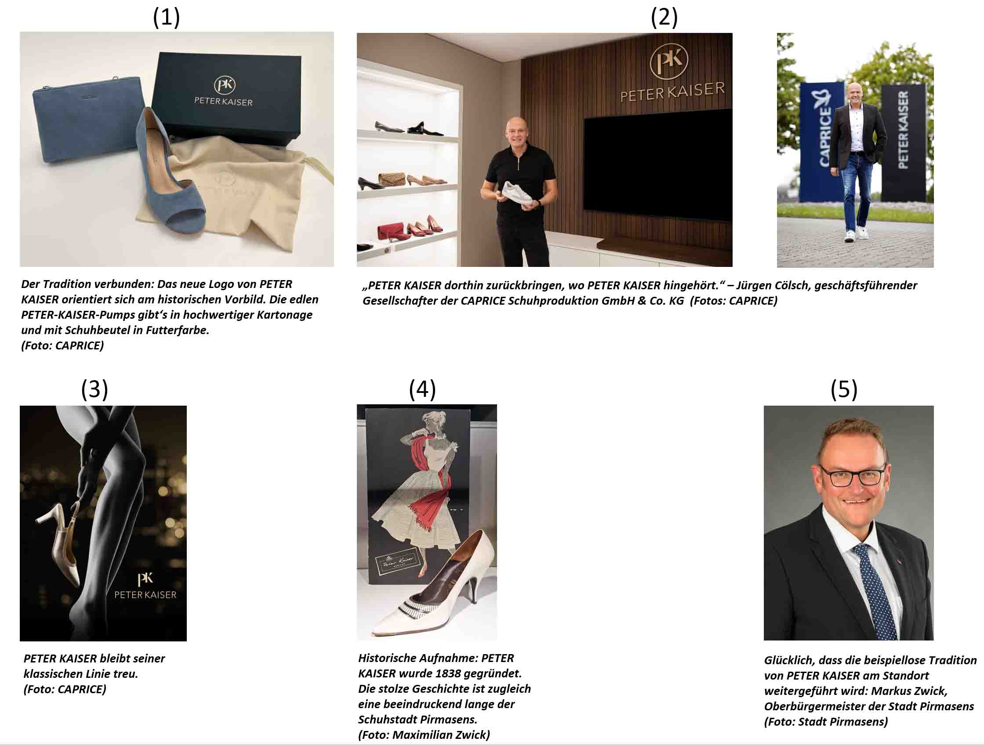

[ Download unter <https://ars-pr.de/presse/20241205_psp> ]

1. The new logo of PETER KAISER is inspired by the historical model. The elegant PETER KAISER pumps are available in premium packaging and come with a shoe bag in lining color. (Image: CAPRICE)
2. Bring PETER KAISER back to where PETER KAISER belongs." – Jürgen Cölsch, Managing Director of CAPRICE Schuhproduktion GmbH & Co. KG (Image: CAPRICE)
3. PETER KAISER remains true to its classic line. (Image: CAPRICE)
4. Historical photo: PETER KAISER was founded in 1838. The proud history is also a remarkably long one from the shoe city of Pirmasens. (Photo: Maximilian Zwick)
5. Pleased that the unparalleled tradition of PETER KAISER continues at the location: Markus Zwick, Mayor of the city of Pirmasens. (Photo: City of Pirmasens)

**Press contacts**

**City Administration of Pirmasens** **ars publicandi Gesellschaft für**

Maximilian Zwick **Marketing und Öffentlichkeitsarbeit mbH**

Leiter der Pressestelle Martina Overmann

Rathaus am Exerzierplatz Schulstraße 28

D-66953 Pirmasens D-66976 Rodalben

Telefon: +49 6331 84-2222 Telefon: +49 6331 5543-13

Telefax: +49 6331 84-2286 Telefax: +49 6331 5543-43

[presse@pirmasens.de](mailto:presse@pirmasens.de) [MOvermann@ars-pr.de](mailto:MOvermann@ars-pr.de)

<https://pirmasens.de> [https://ars-pr.de](https://ars-pr.de/)

**CAPRICE Schuhproduktion GmbH & Co. KG**

Jürgen Cölsch

Geschäftsführender Gesellschafter

Blocksbergstraße 158

D-66955 Pirmasens

Telefon: +49 6331 2733-0

Telefax: +49 6331 2733-33

[juergen.coelsch@caprice](mailto:juergen.coelsch@caprice).de

https://capriceshoes.com